Invasive Species
AWARE
Rats Lesson Workbook

Name: __________________

Class: ________

School: _________________

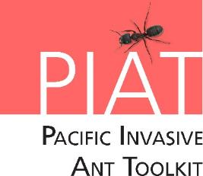
What are we going to learn today?
- What are rats and different types of rats?
- What types (species) of rats are in Kiribati?
- What problems they cause to our people, our agriculture and our natural environment?
- Where did the rats come from and how did they arrive into the country?
- What can you do to stop them – Integrated Pest Management?
What is a rat?
- Like ants and taro beetles, rats are animals. They need air, food and water.
- Rats are ___________ and can be a major pest that damage coconut and other important crops and carry diseases that can harm people.
- Rats can cause the ________________ of threatened species (birds and other animals).
- There are 3 species of rats in the Pacific that can damage crops.
- Rats can _________ quickly when food is available, and weather is suitable.
- Female rats have litters of around 6-10 young and females can produce young more than twice a year.

The Polynesian rat (Rattus exulans)
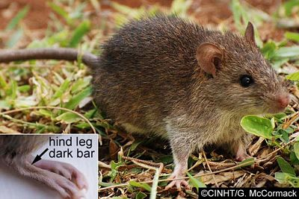
The Polynesian rat. Close-up showing the dark band on the hind foot courtesy and © Gerald McCormack, Cook Islands Natural Heritage Trust.

The black rat (Rattus rattus)
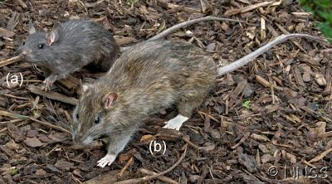
The large features and dark colour of the black rat (a) compared to the larger bodied brown rat (b) courtesy and © Crown Copyright 2009, GBNNSS

The brown rat (Rattus norvegicus)
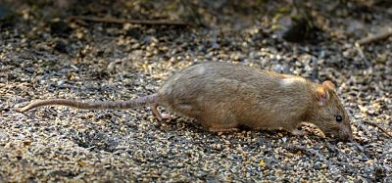
The brown rat showing its short tail and small ears in comparison to its large body size courtesy and © John Hitchmough, Flickr
Some problems caused by rats
- Rats come into homes to look for __________. They can _________ people and spread diseases.
- Rats kill many other animals and birds. Threatened species are very easily killed by rats. Some extinctions of threatened animals have been caused by rats.
- Rats can damage the _________, flowers, trunks and crown parts of the coconut palm through chewing.
- Rats can ________ coconut and other crop products by discharging their faeces and urine on them. The faeces and urine can also cause diseases in humans and other animals.
- Coconut fruits that have fallen and have large _________ are commonly the main sign of rats being present.
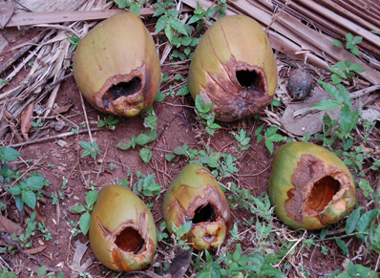
Large holes gnawed in fallen nuts © TNAU
What are some biosecurity actions against rats?
- Biosecurity is how we make sure invasive species and pests do not arrive in the country or spread to cause more harm in our environment.
- Rats can also _________ a long way and travel between islands.
- Rats are frequently found hiding on boats, ships and aircraft.
- Ships and aircraft should be regularly ______________ for the presence of rats.
- Most countries have some form of biosecurity for docking ships.
- The ___________ of rats is prohibited into and out of many countries.
What is Integrated Pest Management?
- IPM means using a combination of approaches to control pests or diseases.
- The 3 parts are cultural, natural and chemical.
Integrated Pest Management (IPM)
Cultural Approach | Natural Approach | Chemical Approach
Rats are commonly introduced from and found around human populations.  Therefore, keeping environments clean and tidy and storing food resources tightly can help reduce rat populations. | Trapping is a great option to catch all species of rats and help with identifying what species is present. Snap traps and live traps can be used.  More than 3 nights of trapping should be completed as the brown and black rat (dominant species) are generally caught first then the Polynesian rat the remaining nights. | Baiting with pesticides or rodenticides is commonly used as a control or eradication tool.
- New sighting of rats should be reported immediately to the nearest wildlife authority or relevant government department.
- Predators should never be introduced to control rats.
- Removing one species of rat can make areas more vulnerable to other species as it reduces their competition. Therefore, all three rat species should be focused on equally.

What you have learnt today
- Rats are animals. They need air, food and water.
- The Polynesian rat, the black rat and brown rat can be found in the Pacific. Rats are mammals and can be a major pest that damage coconut and other important crops.
- Biosecurity is needed to stop rats moving from island to island and between countries.
- The Integrated Pest Management approach involves cultural, natural and chemical methods.

Notes

